Taj is a large hospitality firm with resorts and hotels in popular tourist areas.

Taj offers top-notch service in serene settings, together with innovative architecture and life-changing experiences at some of the most exclusive metropolitan addresses and resort locations on earth.

1. Website Examples (Inspiration)

[Airbnb](https://www.airbnb.com.au/?tab_id=home_tab&refinement_paths%5B%5D=%2Fhomes&search_mode=flex_destinations_search&flexible_trip_lengths%5B%5D=one_week&location_search=MIN_MAP_BOUNDS&monthly_start_date=2023-09-01&monthly_length=3&price_filter_input_type=2&price_filter_num_nights=5&channel=EXPLORE&search_type=category_change&category_tag=Tag%3A4104): Airbnb is an online market place for short-term and long-term stays and experiences. They host thousands of houses for the customers to choose from. They have a very simple and intuitive website which makes it easy for the user to book a stay.

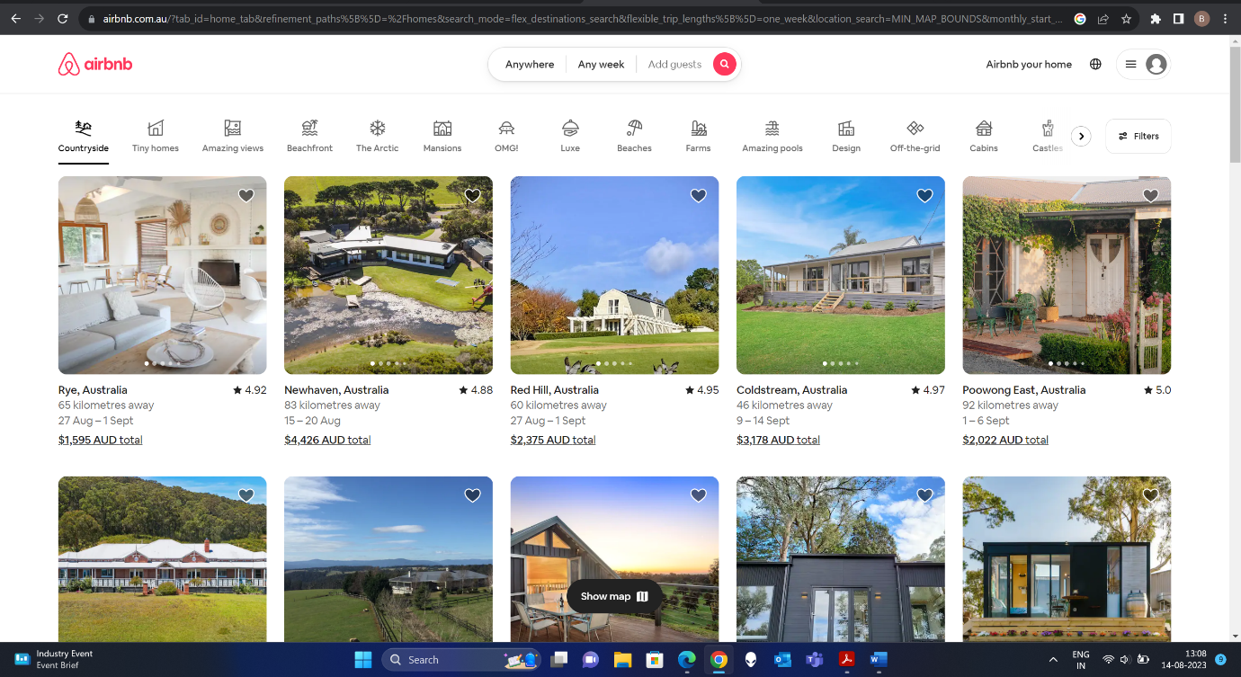

The above figure shows the home page of the website, the features that are creative and help in making an effective website are as follows:

* A filters option at the top of the webpage allows the users to choose the type of stay they are looking for. This filters bar uses icons along with text to give a better visual appeal to the webpage.
* Each stay or property is listed below like a card feature which shows the image along with the property information such as the name, address, availability and rating.
* Each card has a carousel feature that shows various images of the property. This allows the user to view multiple images without actually opening that particular property card.

[Shangri-La Hotel](https://www.shangri-la.com/?WT.mc_id=SLIM_20200224_GLOBAL_SEM_GOOGLE_ALWAYSON_BRAND-EXACT-TEXTLINK_AON2019_EN-RSA-SL-Shangri%20la&&&&&ds_rl=1247775&ds_rl=1272902&ds_rl=1272902&gclid=CjwKCAjw_uGmBhBREiwAeOfsd1LZTJitvaKzucXvLTvZy5eWxsZ4lXJz45C_sGPYf0a8-aFHMOYdzhoCUyIQAvD_BwE&gclsrc=aw.ds): Shangri-La group consist of a more than 100 hotels and resorts in almost 22 countries. They also offer various fine dine restaurants and events places for the customers.

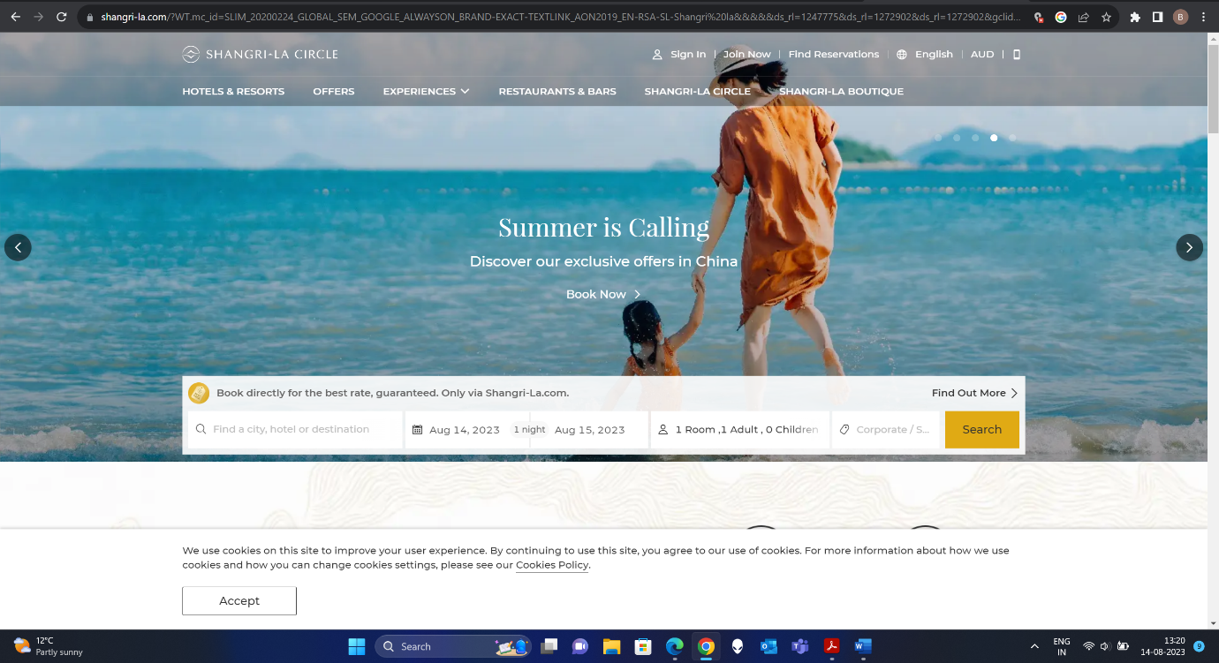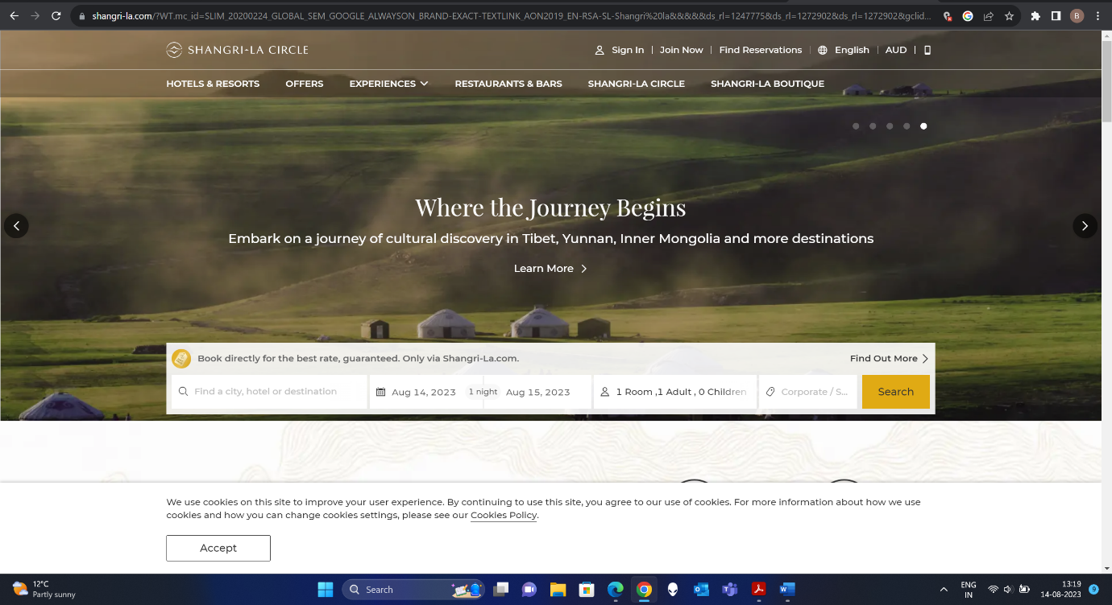

The above pictures show the hotel group’s website, the features that are creative and help in making an effective website are as follows:

* Carousel: Website features a carousel with different images and it also acts as a navigation features. Each carousel slide has a hyperlink to a new webpage that allows the user to navigate to that particular feature. As seen above the user can either book a summer vacation by clicking the first image or can explore vacation options in Tibet, Yunnan and Mongolia by clicking on the second image.
* Website also features a search bar within the carousel image which makes it easier for the user to use the search option.

[The Serai Chikmagalur](https://www.theserai.in/chikmagalur-resort/): The Serai is a beautiful resort on the foothills and on the slopes of western ghats in India. It hosts 29 villas with every villa having private pool and right next to the coffee plantation. They have a very informative and a creative website.

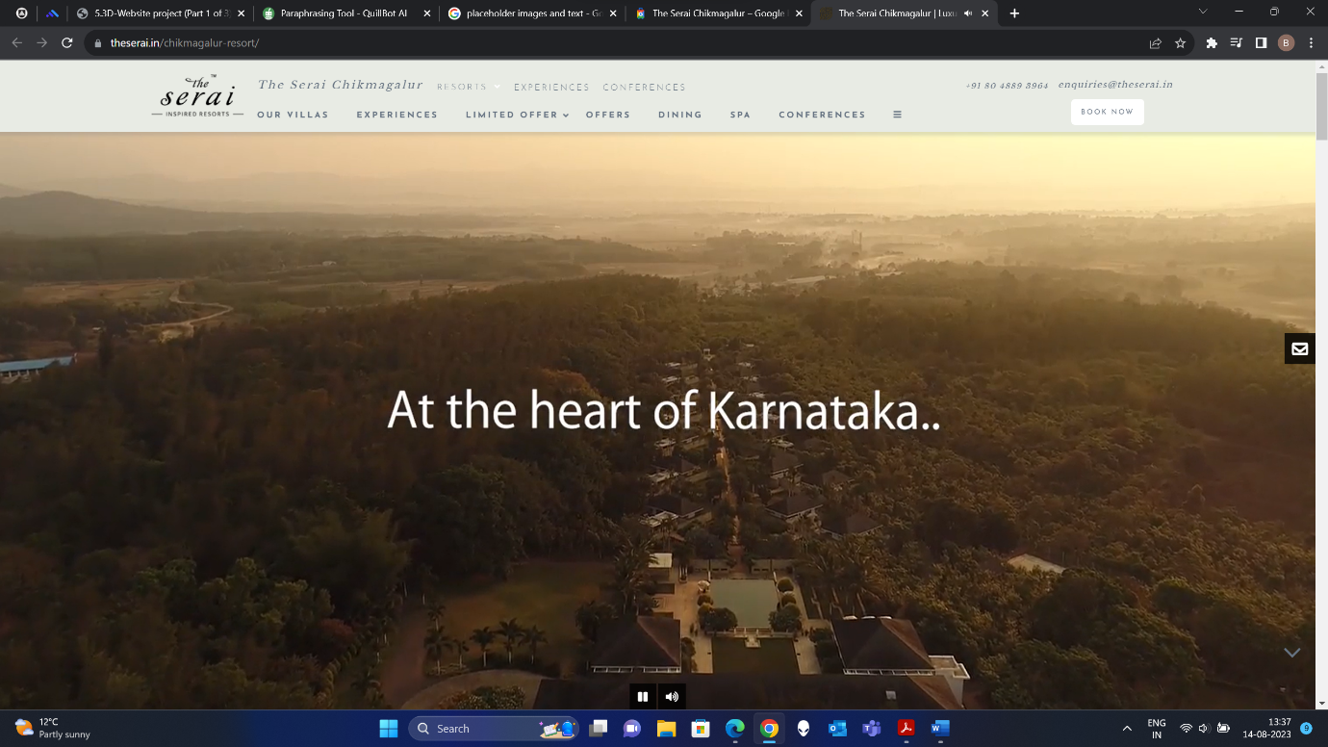

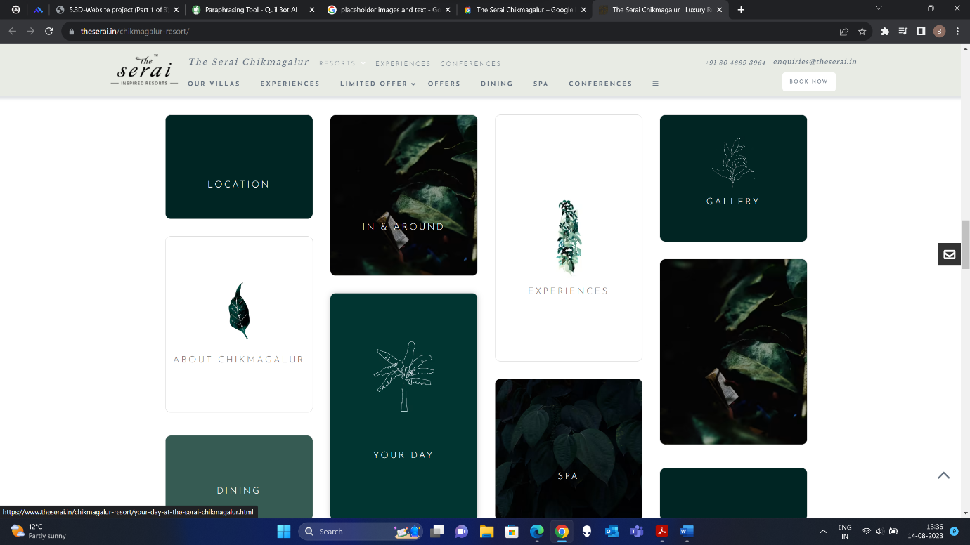

The above pictures show the resort’s website, the features that are creative and help in making an effective website are as follows:

* Informative introductory video: Website plays an informative video on the website’s home page. This allows user to see and know more about the resort and the experiences they are going to provide.
* Hyperlinked Cards: Website features a set of cards which when clicked takes the user to the respective webpages. The cards use a simple colour theme of shades of green. This look very appealing to the users who view the webpage.

1. Site Map:

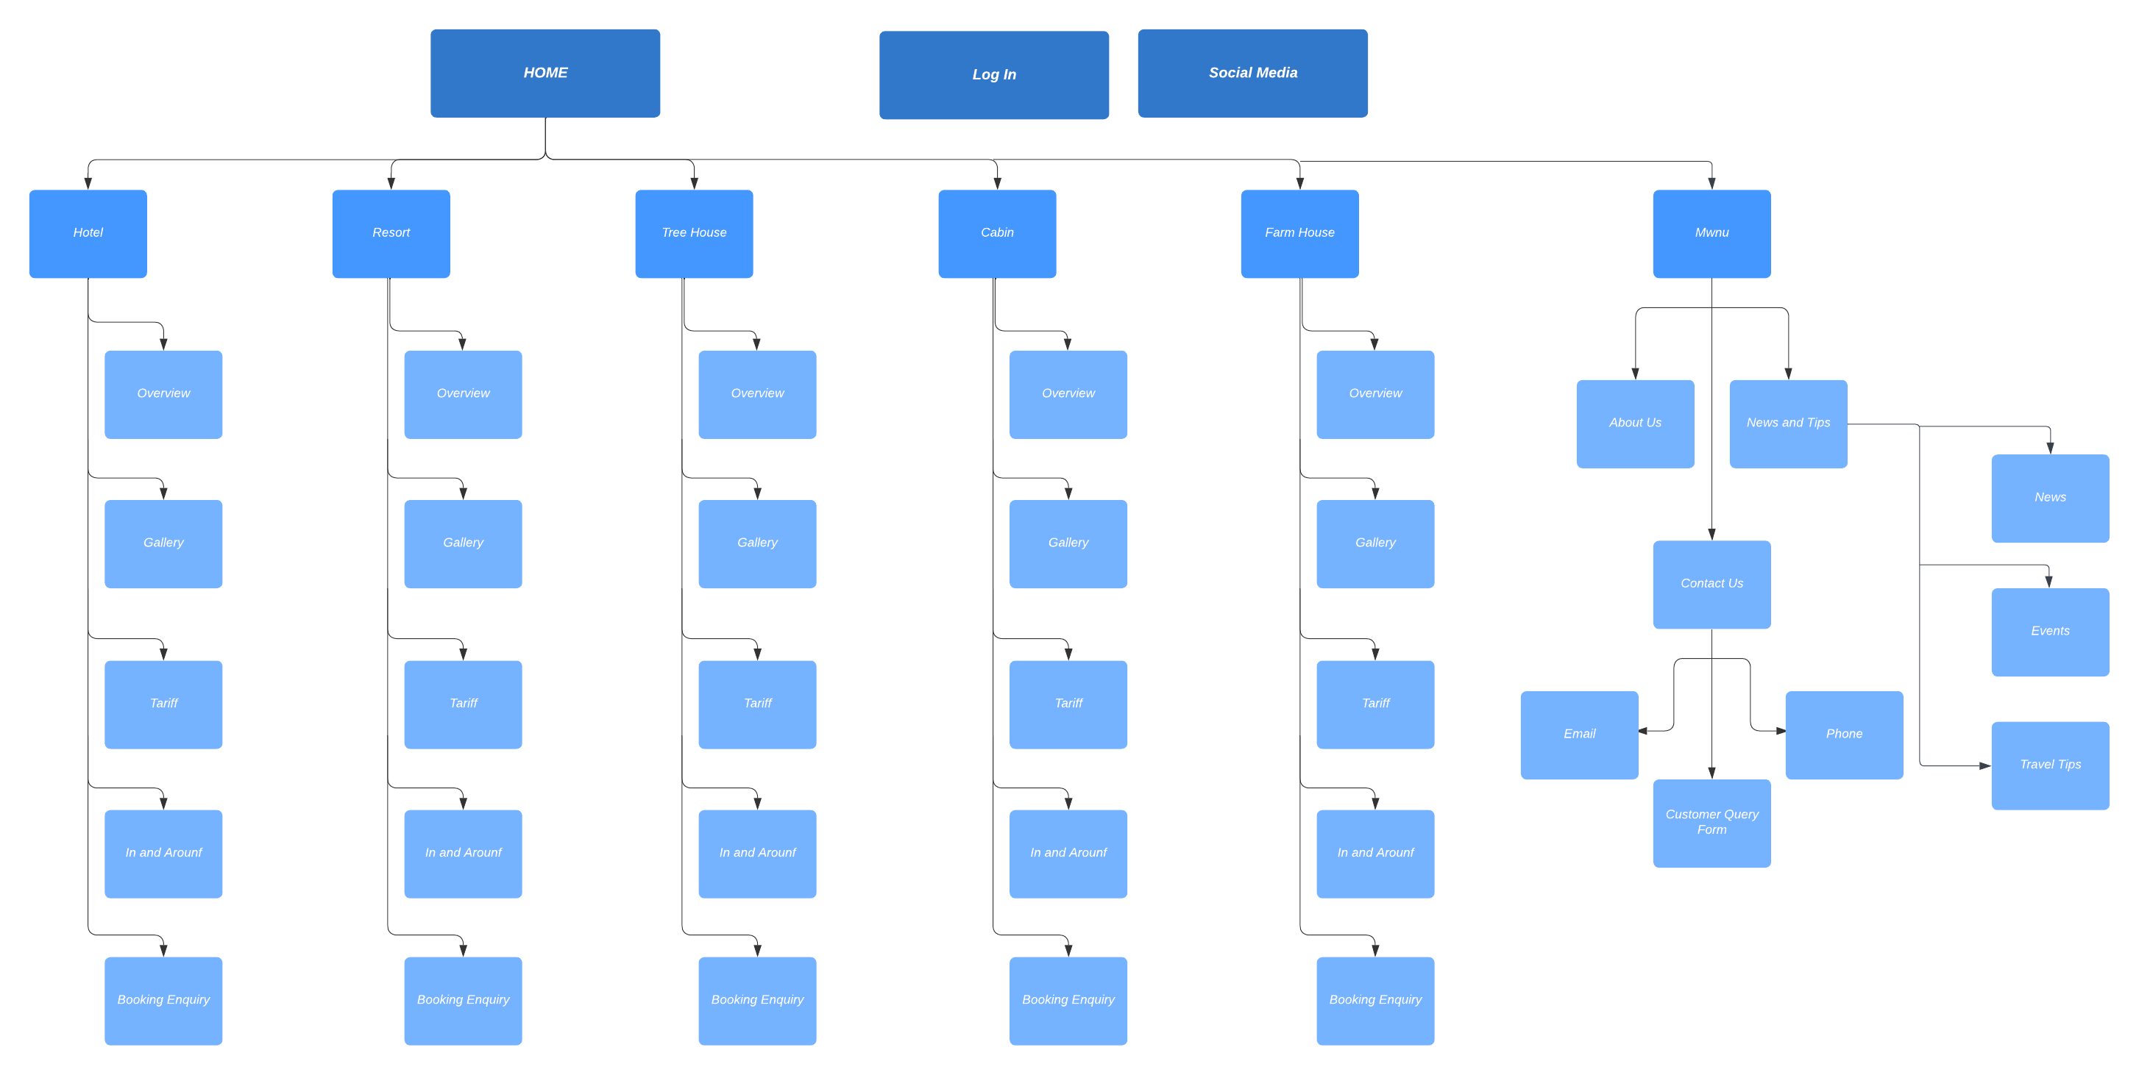

Figure represents the site map for the website. The website consists of various webpages for each type of stay as shown. It also hosts a dropdown menu which has link to About Us, Contact US and the News sections.

Each type of stay has a separate webpage with all the necessary details such as the stay overview, Gallery, Booking section and In & around section.

1. Webpage Wireframe

* Home Page: 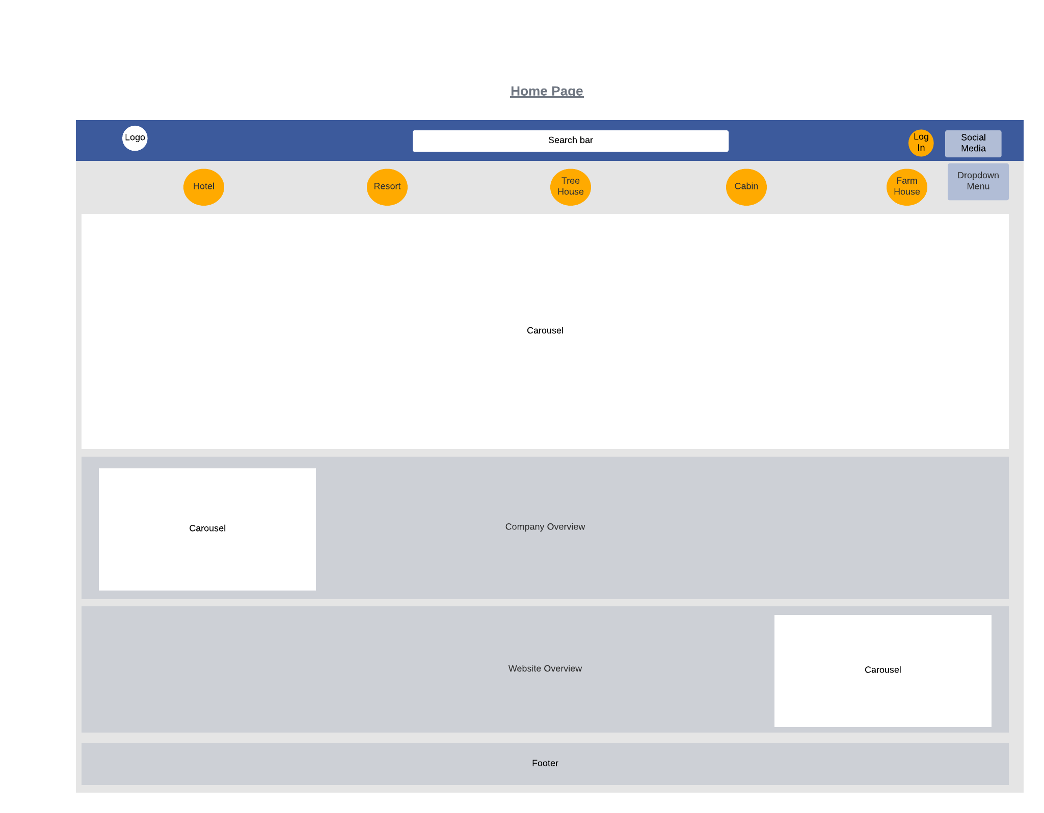

Image

Image

* Hotel Webpage:

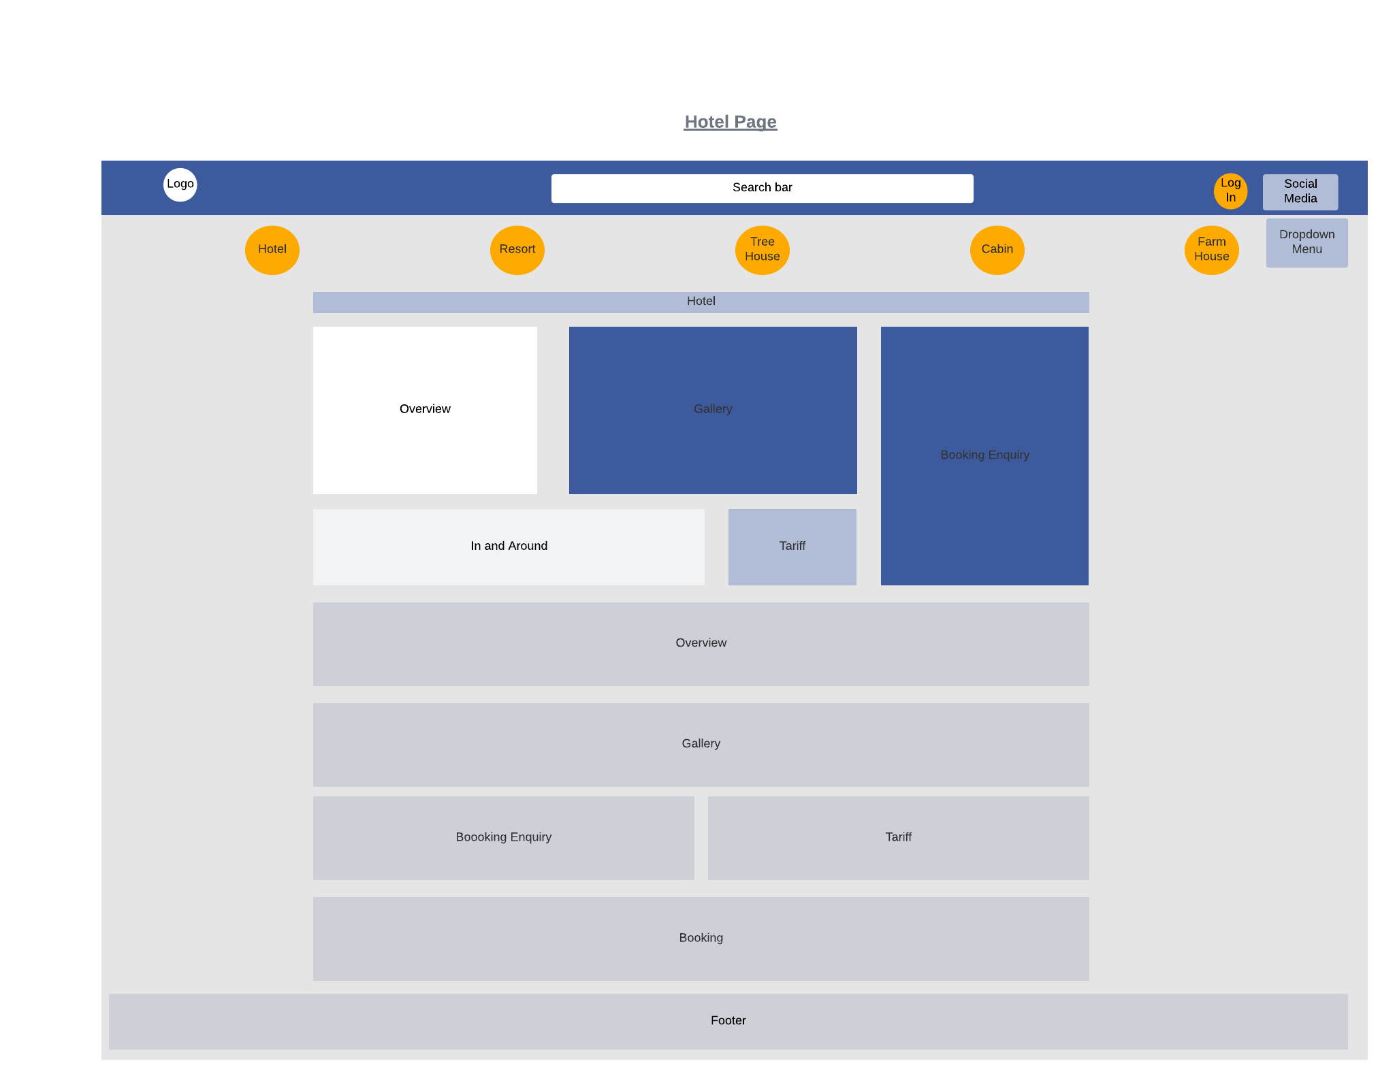

* Resort Webpage:

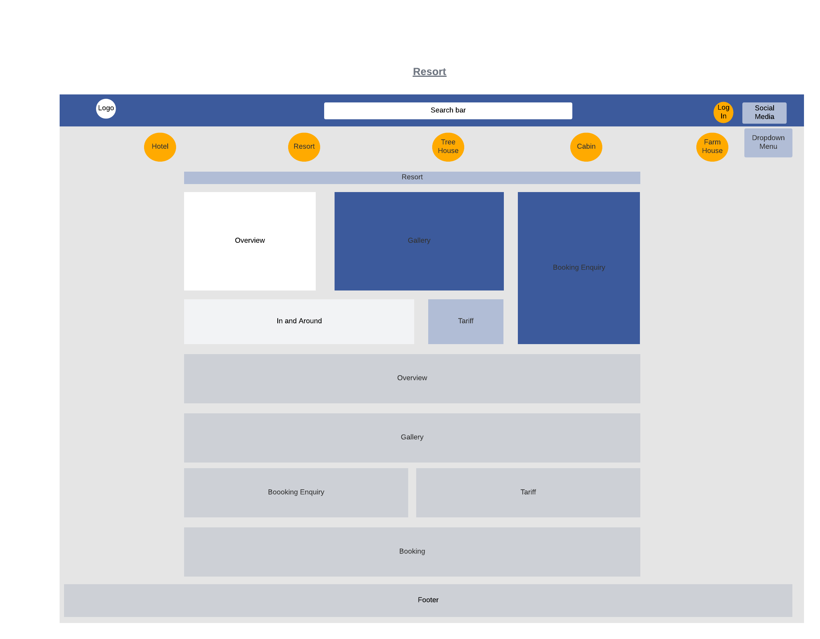

* Tree House Webpage:

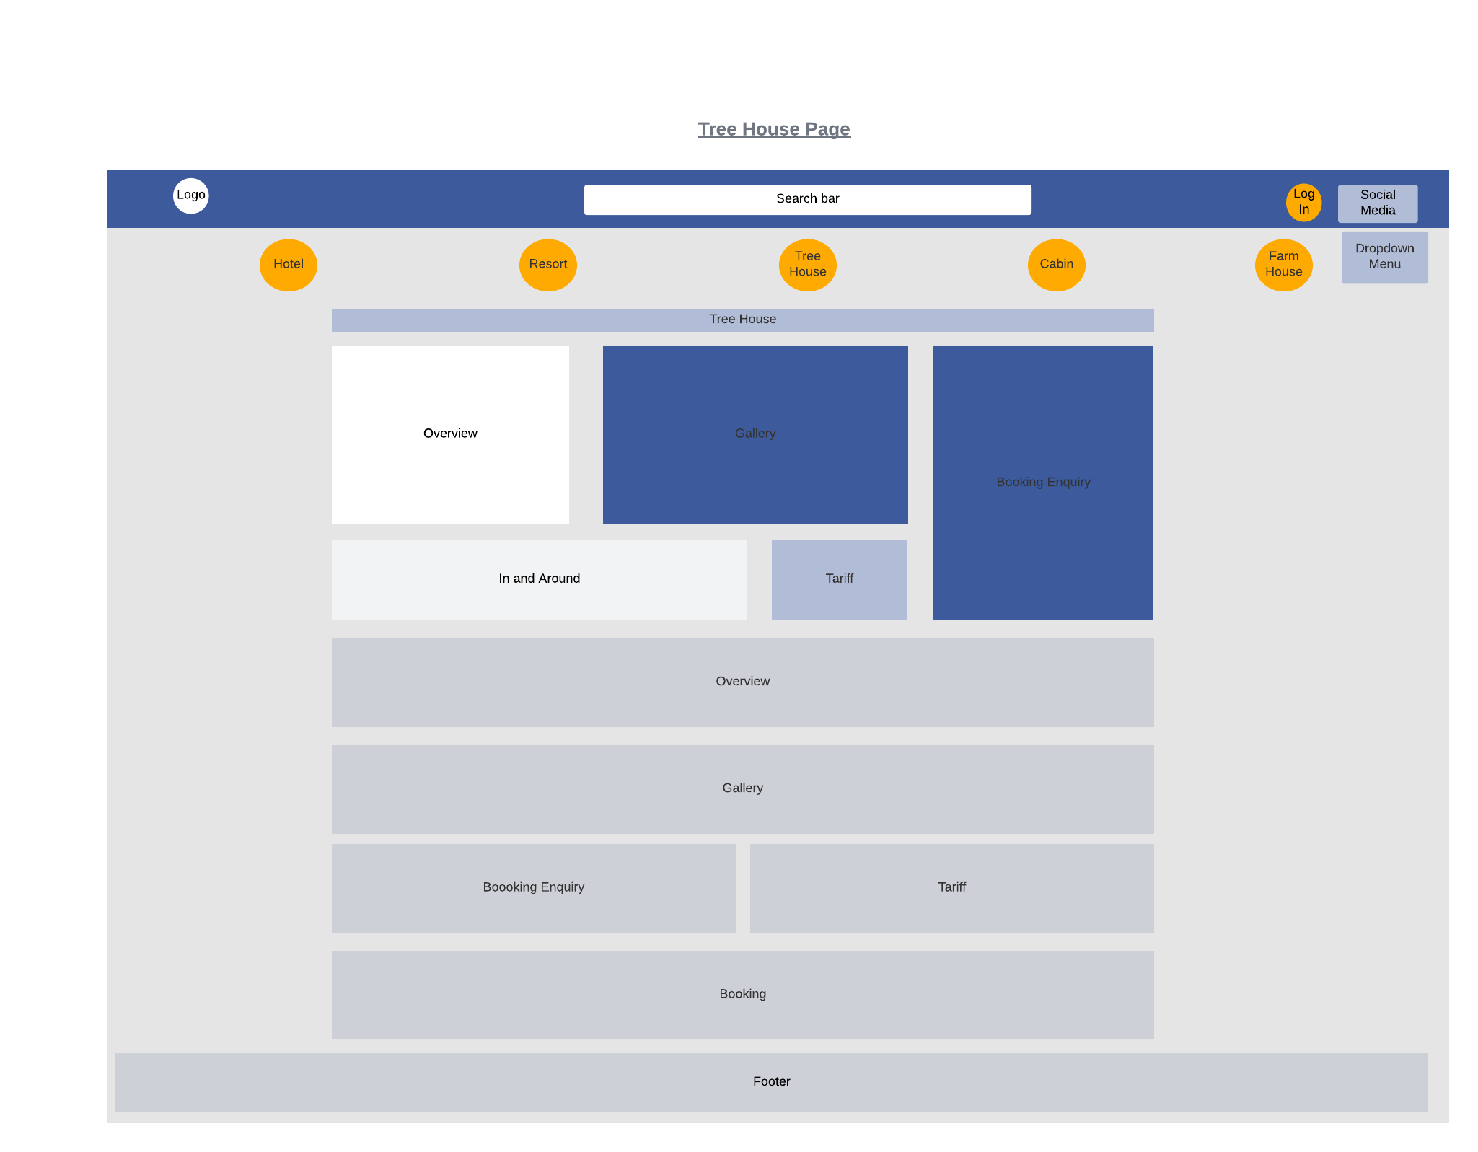

* Cabin Webpage:

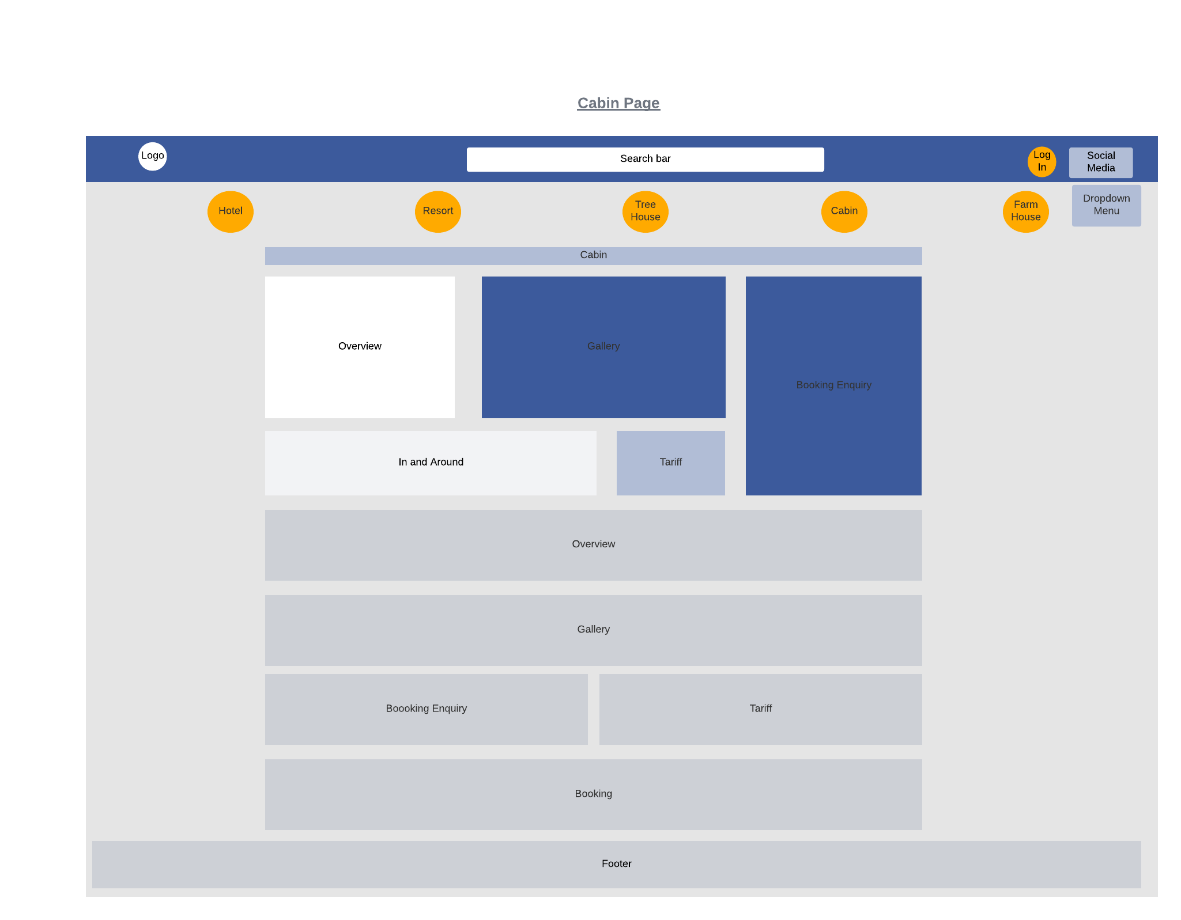

* Farm House Webpage:

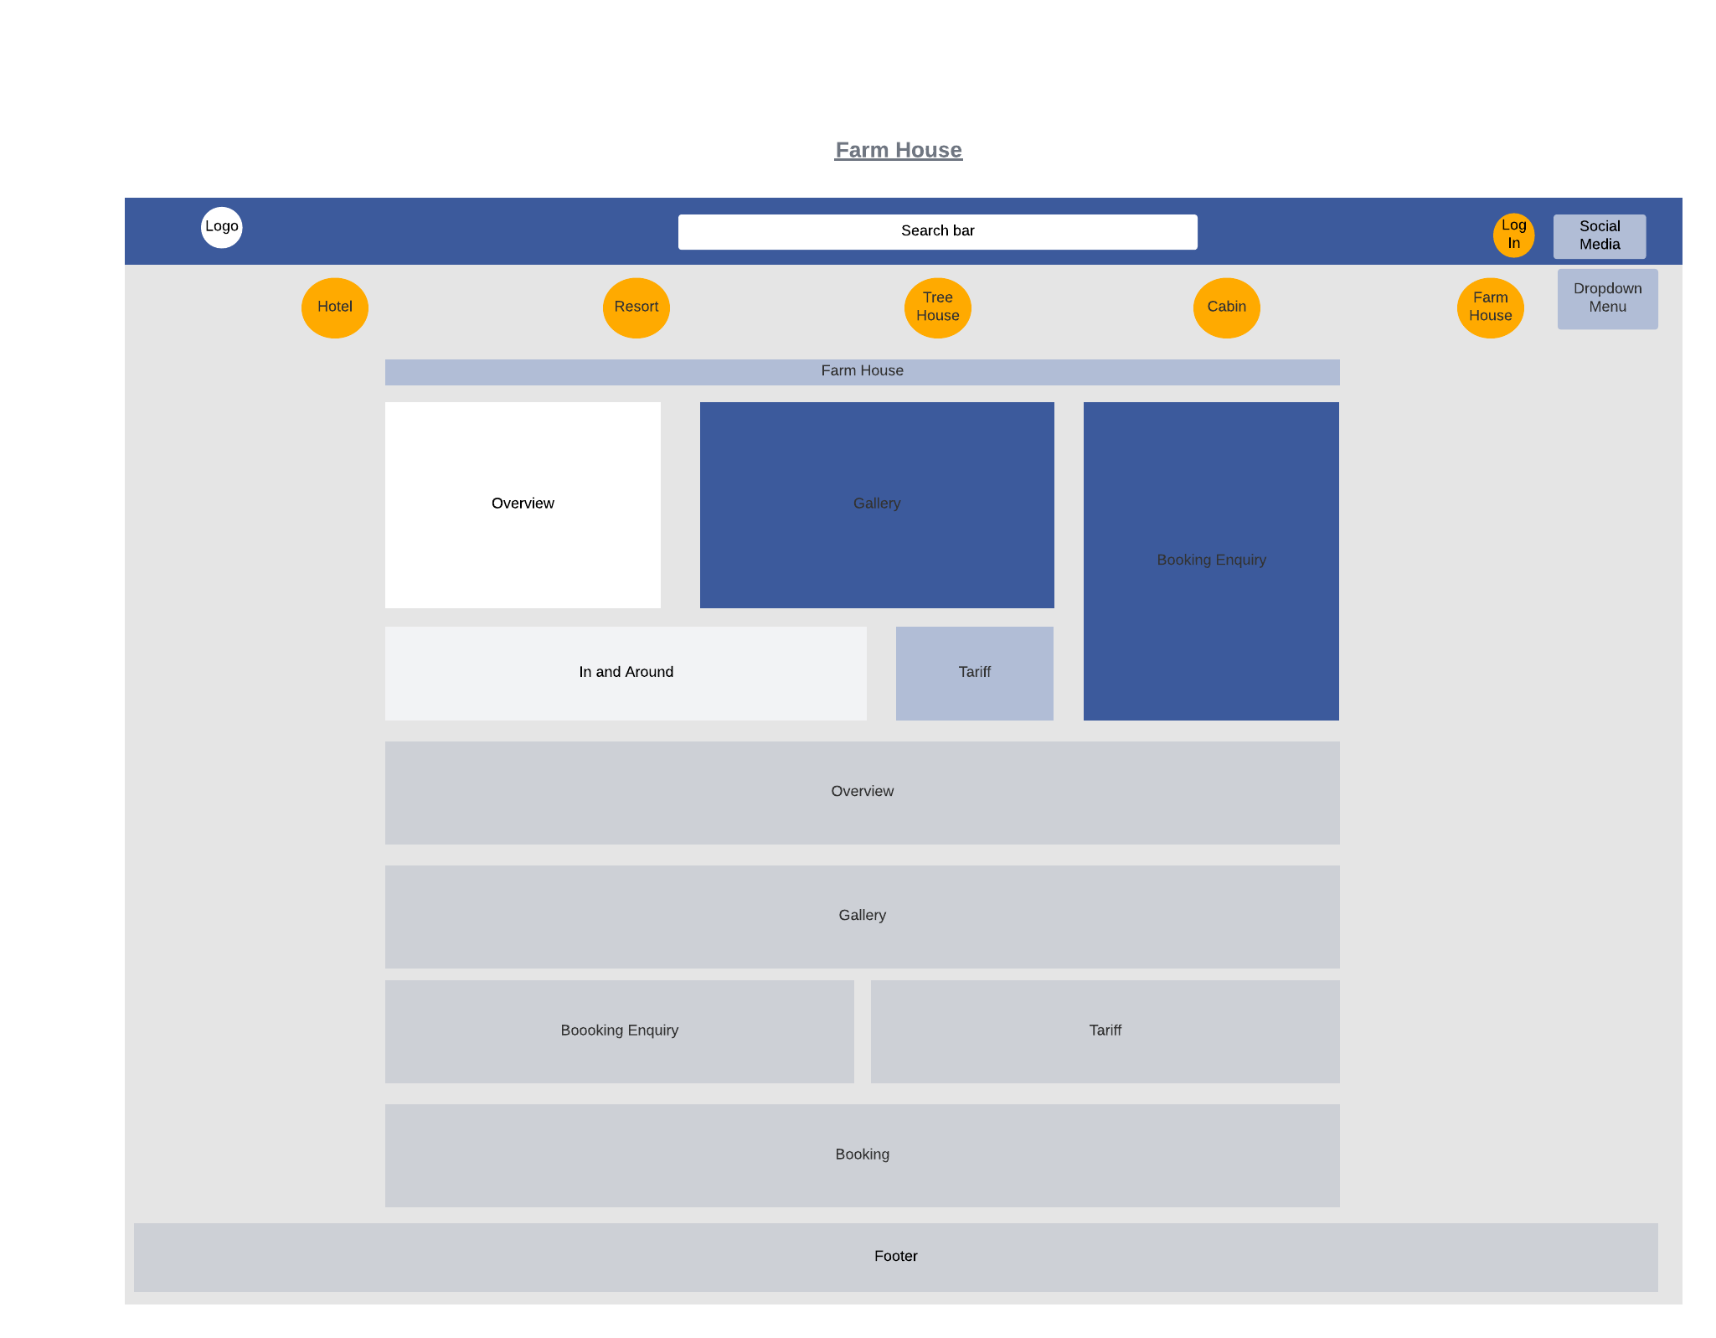

* News Webpage:

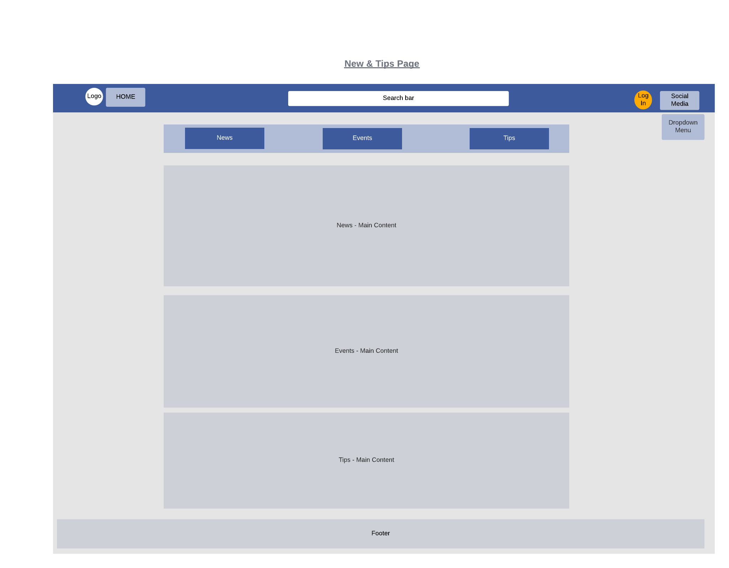

* Contact Us Webpage:

